doctors profile

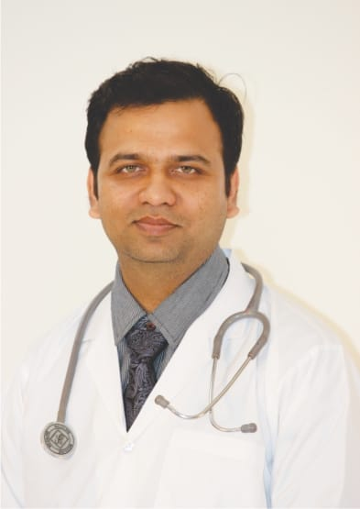
Dr Ashish Mohide
MBBS, DPM, DNB
Consultant Neuropsychiatrist
Deaddiction Specialist
QUALIFICATION AND EXPERIENCE-
*MMBS ﻿﻿DPM & DNB (Diplomat of National Board)
* ﻿﻿One year of training in Centre of addiction Medicine at NIMHANS, Bengaluru
* ﻿﻿Training in Child psychiatry at NIMHANS
* ﻿﻿Training in Psychotherapy at NIMHANS
* ﻿﻿Training in Industrial Psychiatry and Community Psychiatry at IPH, MUMBAI
* ﻿﻿Senior Resident in MGM's medical college, Aurangabad
* ﻿﻿Consultant Psychiatrist Since 2015 in Aurangabad
Achievements and Attachments:
- *Consultant psychiatrist at ORIION CITY CARE and PENTAGON SUPERSPECIALITY hospital
- Ex Secretary and treasurer of INDIAN PSYCHIATRICS SOCIETY AURANGABAD
- Trustee and founder member of PANKH FOUNDATION working for mental health awareness
- Trustee of I progress working for special children
- Team member of AASTHA FOUNDATION and SNEH SAWALI working for JOYFUL OLD AGE
- Team member of SAFU working for women empowerment and deaddiction
- Consultant psychiatrist for SRPF -14 jawans
- Counselor in Stepping Stone School

﻿Social Contribution:
* ﻿﻿Multiple mental health awareness programs
* ﻿﻿Screening camps for psychiatric disorder & dementia
* ﻿﻿Workshops for stress management in exam going students & Industries
Free night visits and deaddiction camp in 30 remote villages of sambhajinagar

